|  |  |
| --- | --- |
| **Automatic Garage Door** | |
|  | **3** |

|  |  |  |  |  |  |  |
| --- | --- | --- | --- | --- | --- | --- |
| **PARTS NEEDED** | Base Plate  http://images.studica.com/images/product/fischertechnik/86grundplatte.jpgx1 | mySTEM Board  mySTEM™ Project Board for NI myDAQx1 | NI myDAQ  NI myDAQ for Secondary Schoolsx1 | DC Motor  32293: S-MOTOR 6-9V x1 | Photo Transistor  36134: PHOTO-TRANSISTOR ASSEMBLEDx2 | Ball Lamp  37869: BALL LAMPx2 |
| Limit Switch  37783: MINI-SWITCHx2 | Building Block  32850: BUILDING BLOCK 15 X 15 x1 | Light Holder  38216: PLUG IN LIGHT HOLDER x2 | Axle with Clip  32870: AXLE WITH CLIP  x2 | Gearbox  31078: Motor Reducing Gearbox Black x1 | Rack & Pinion  37351: RACK & PINION 60  x2 |
| I-STRUT 90  31765: I-STRUT 90  x2 | Strut Adapter  31848: STRUT ADAPTER RED x2 | Spring Cam  31982: SPRING CAM x3 | Bore Block  32064: BUILDING BLOCK WITH BORE x4 | Block 15  32881: BUILDING BLOCK 15 x15 | Axle 45  35064: WHEEL AXLE 45  x1 |
| Girder 15-2pins  36298: ANGLE GIRDER 15 WITH 2 PINS x3 | Girder 120  36293: ANGLE GIRDER 120 BLACKx3 | Girder 60  36297: ANGLE GIRDER 60 x4 | Girder 30  36299: ANGLE GIRDER 30 x3 | Statics Block  35076: STATICS BUILDING BLOCK x3 | Rivet 4MM  36323: SINGLE RIVET 4 MM RED x9 |
| I-Strut Bore 45  36913: I-STRUT WITH BORE 45 BLACK x4 | Angle Girder 30  36920: ANGLE GIRDER 30 BLACK x3 | Angle Girder 60  36921: ANGLE GIRDER 60 BLACK x1 | Angle Girder 15  36950: ANGLE GIRDER 15 WITH 2 PINS x1 | Spring Ring Clip  37679: CLIP 5 WITH SPRING RING x4 | Angle Block  38423: ANGLE BLOCK 10 X 15 X 15 x1 |
| Building Plate  38428: BUILDING PLATE 15X30X5 WITH 3 GROOVES x1 | Hinged Block  31436: HINGED BLOCK CLAW x1 | Locking Washer  36334: LOCKING WASHER RED x2 | Block 30  32880: BUILDING BLOCK 30 WITH BORE x5 |  |  |

|  |
| --- |
| Assemble |

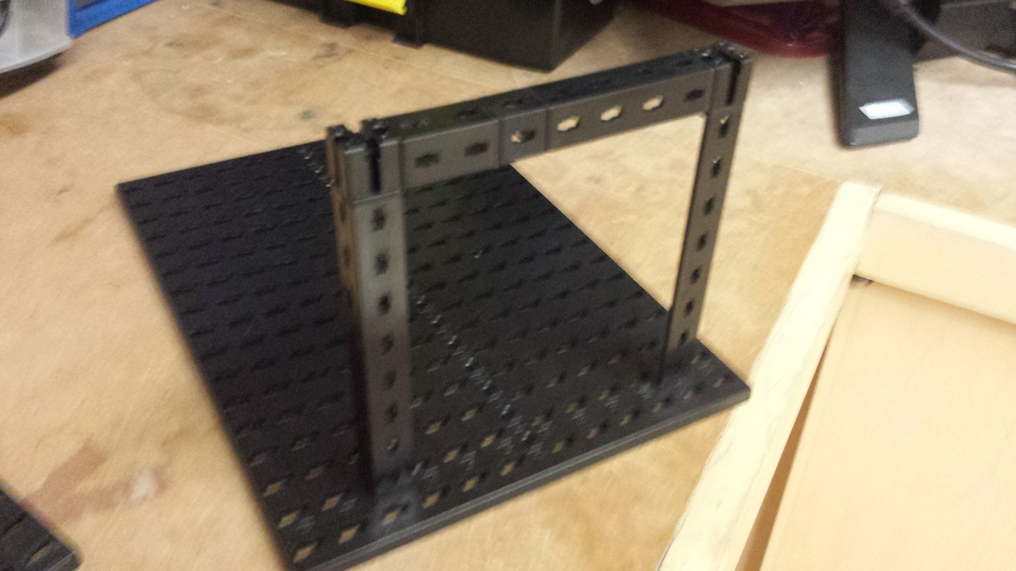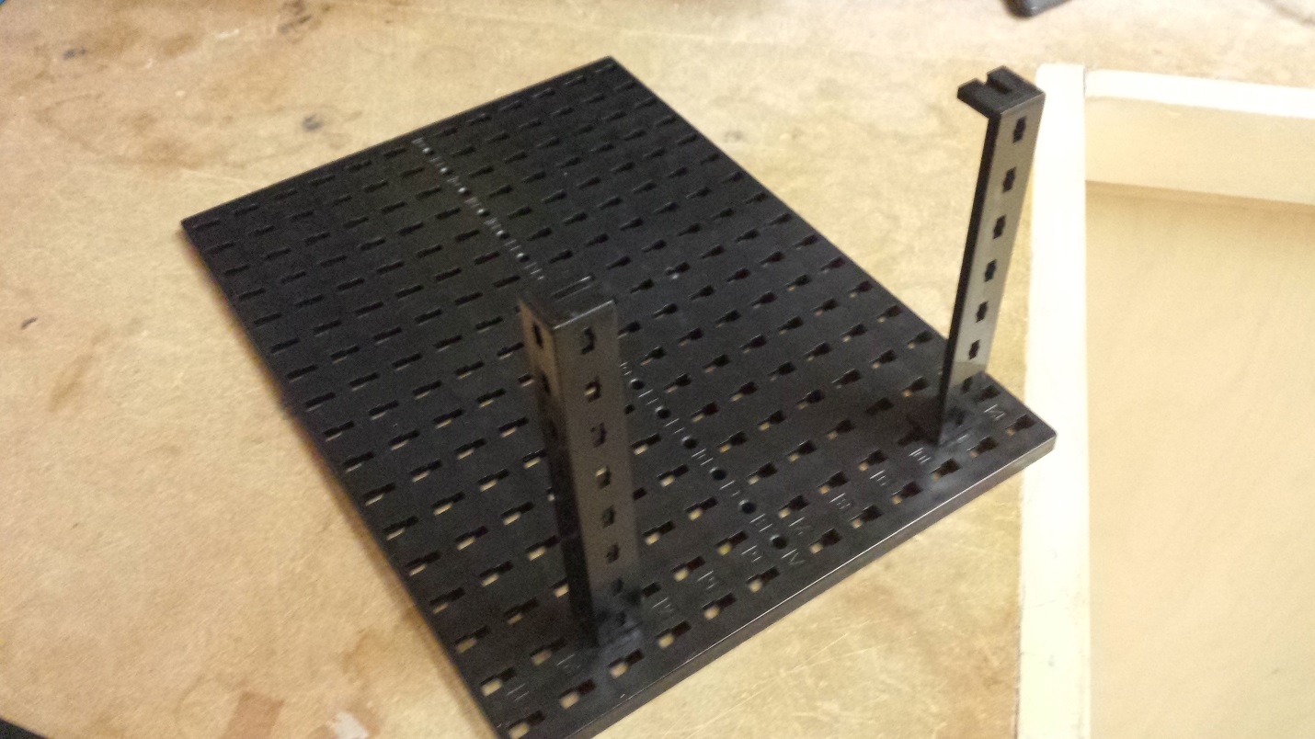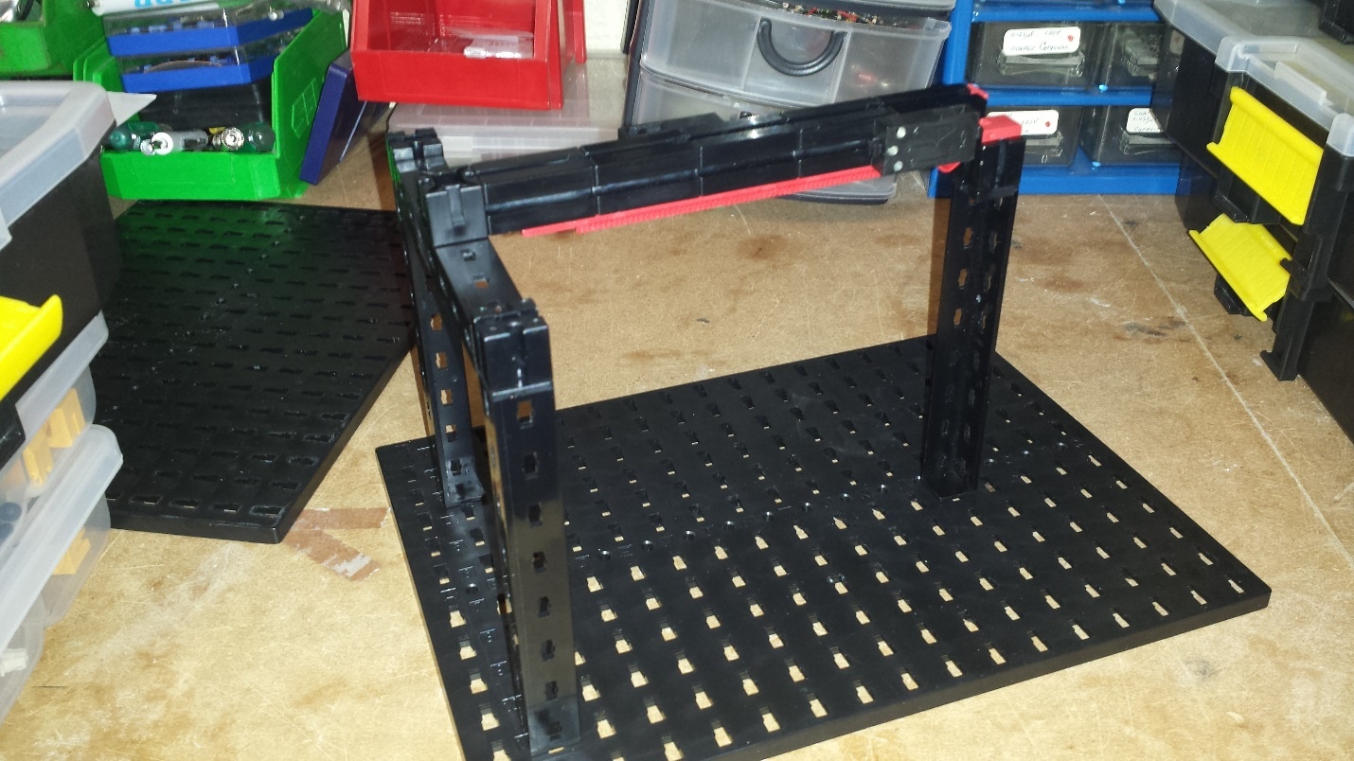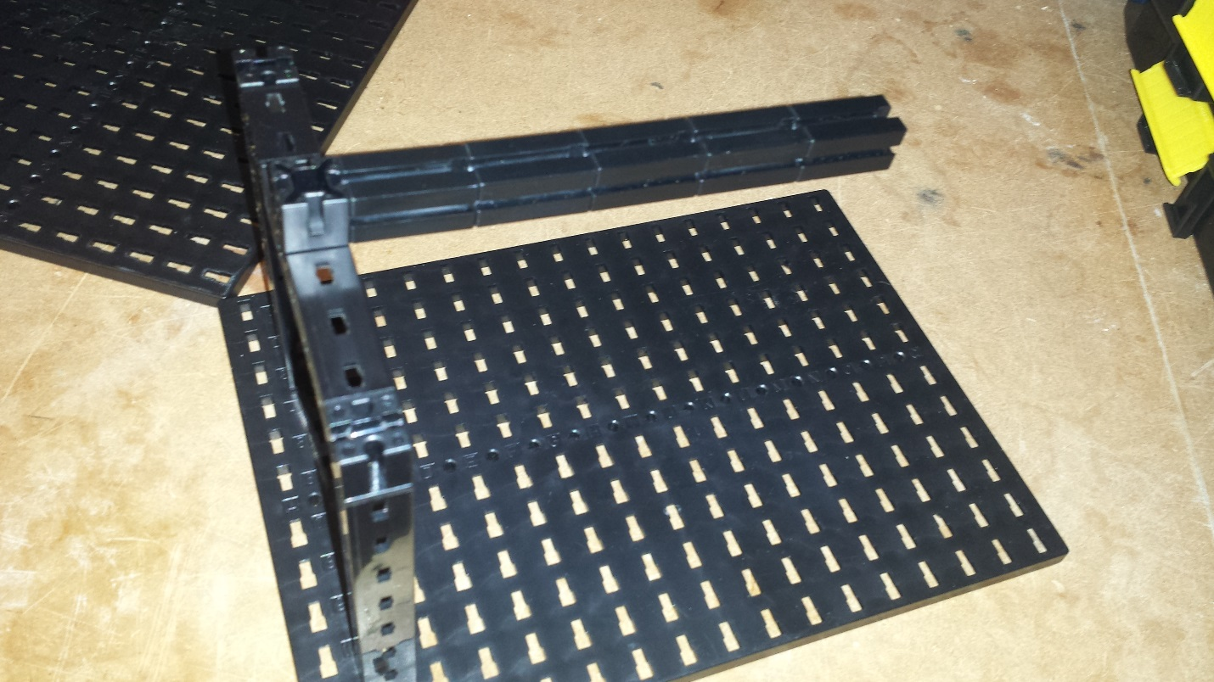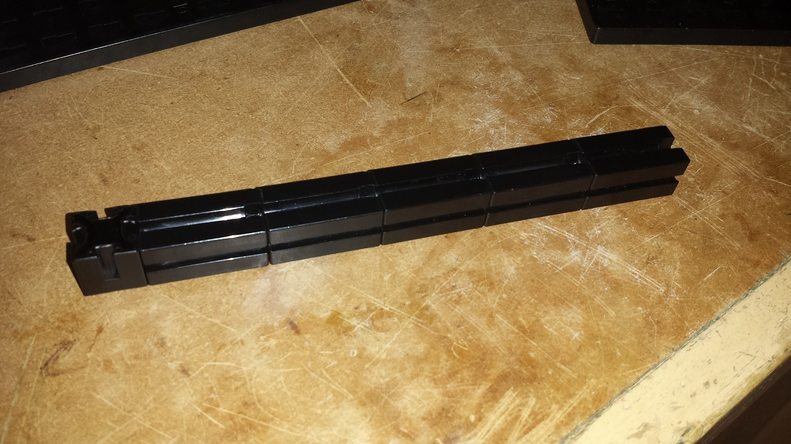

**Add a second Girder 120 to B11**

**Connect Angle Girders 15, 30 and 60 together. Attach them in between the two Block 15**

**Place Block 15 on top of both Girders**

**Add Girder 120 to B3 on base plate**

**Connect five Block 30 , two Block 15 and one Building Block together**

**Attach two Limit Switches**

**Connect Girder 120, Angle Block and Block 15**

**Attach Girder 120 to O7**

**Attach this on top**

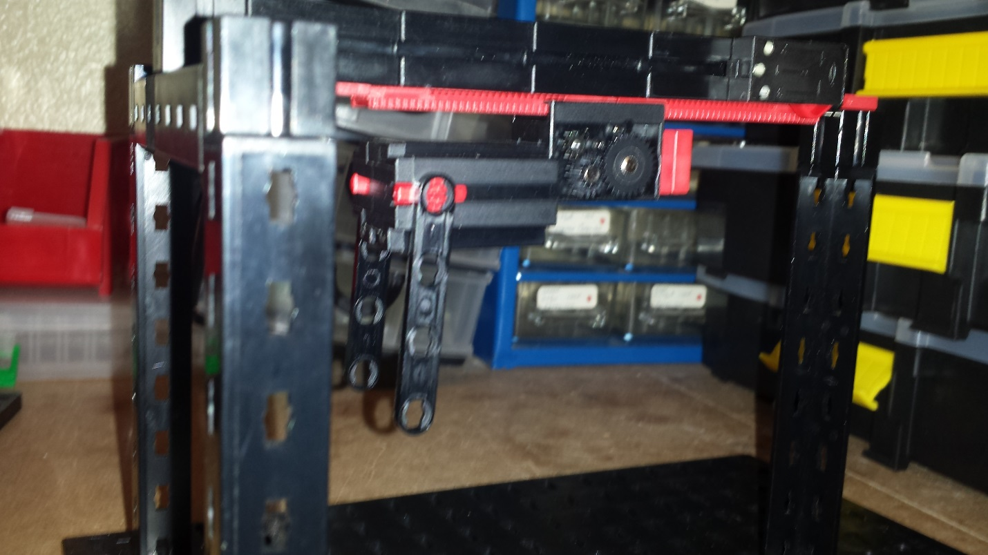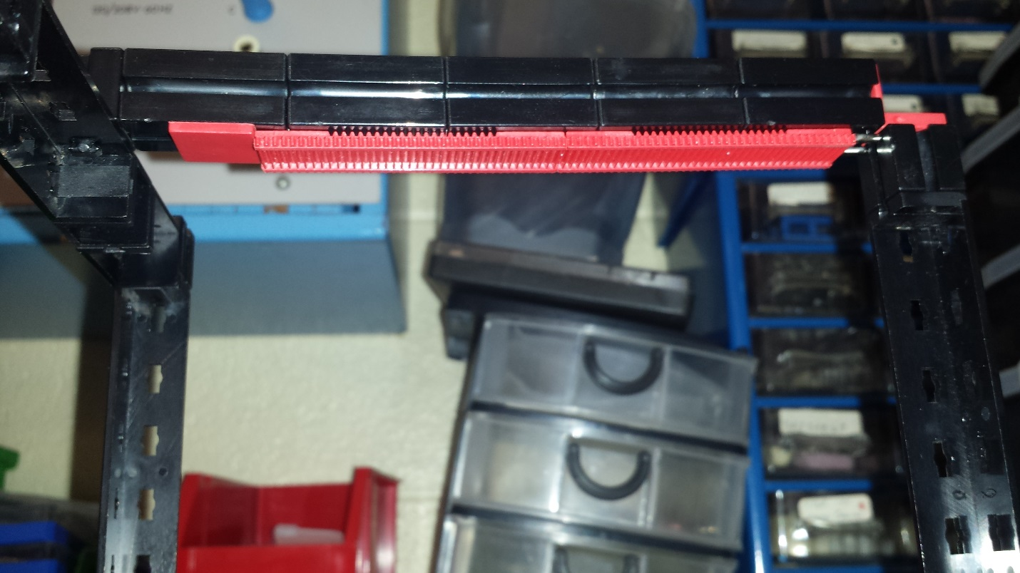

**Use two Strut Adapters to attach two I-Strut 90 to the motor**

**Attach DC Motor to Rack & Pinion**

**Optionally, add a plate for aesthetics**

**Attach Rack & Pinion**

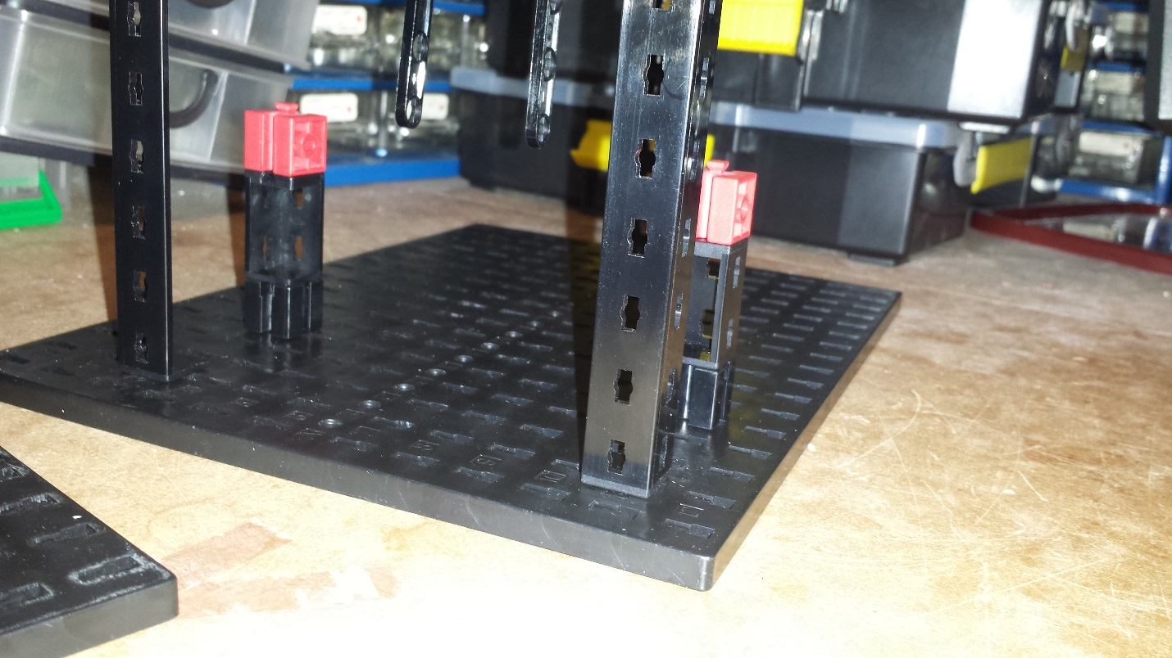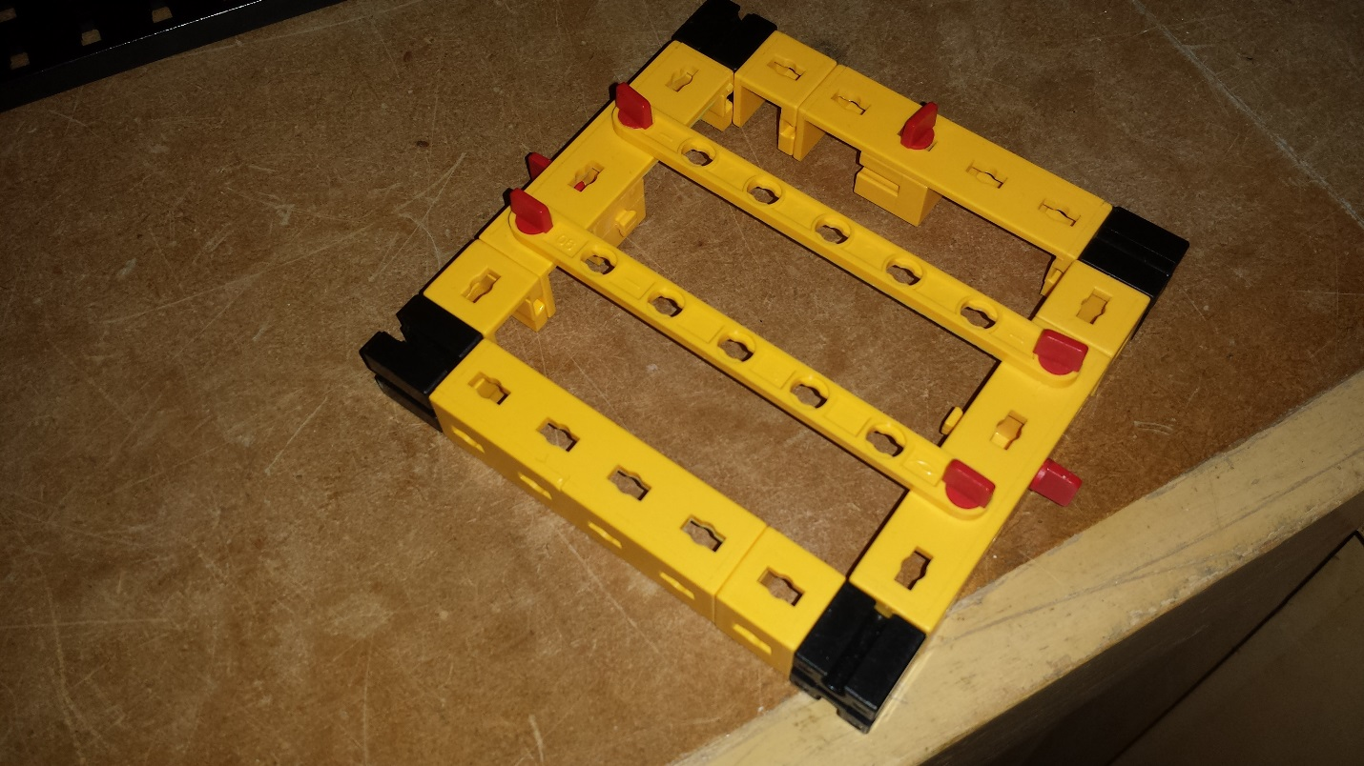

**Use Bock 15 and Girder 60 to make a square gate**

**Place second pillar on E3**

**Place first pillar on E11**

**Use Angle Girder 30, Block 15 and Bore Block to create two pillars**

**Use 4MM Rivets to add two I-Strut 90 in the middle of the gate**

**Add a 4MM Rivet to each Statics Block**

**Attach Statics Block on the center of these three edges**

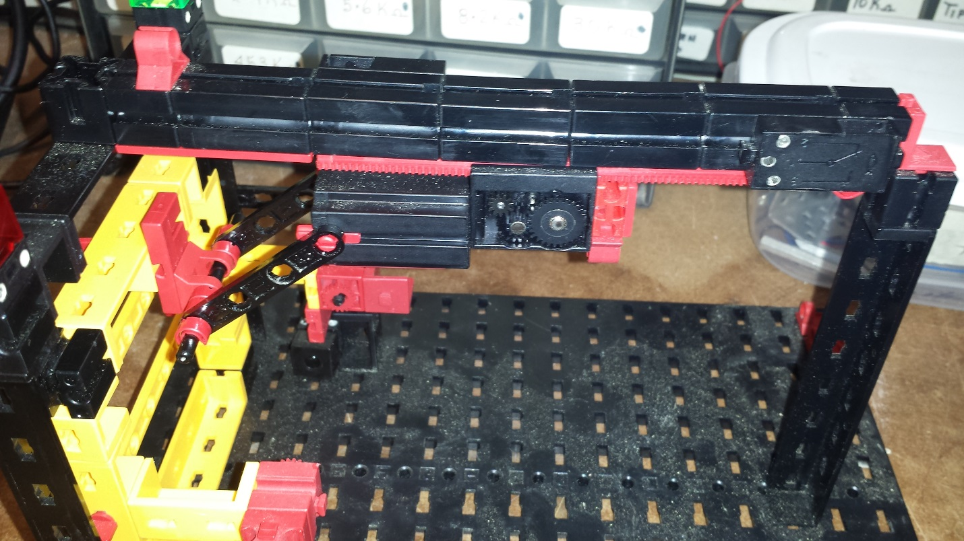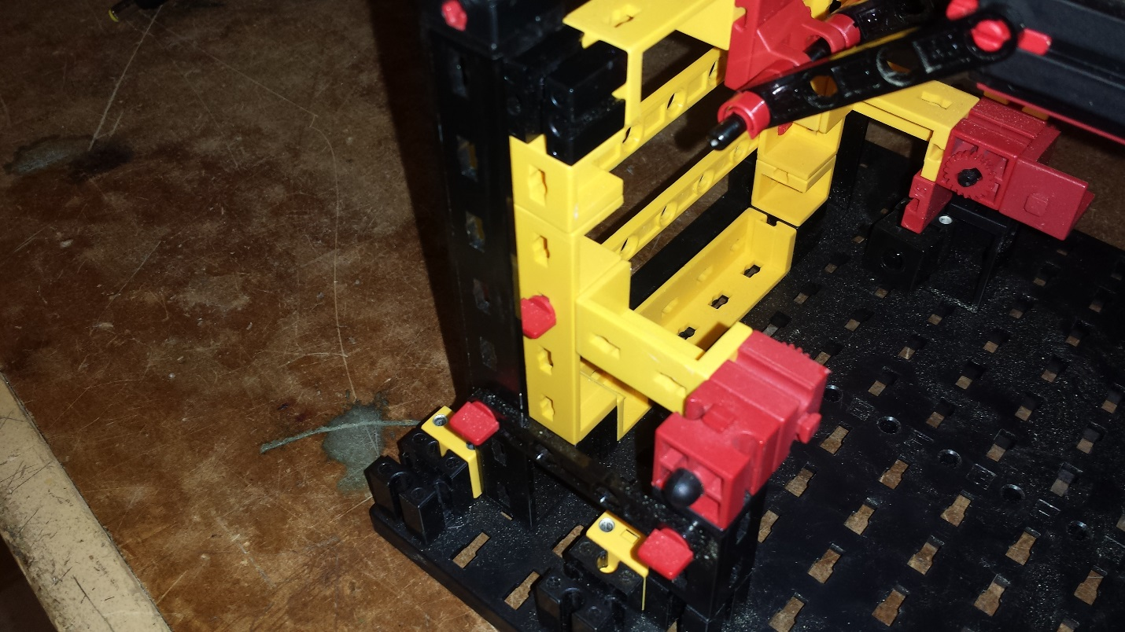

**Attach Bore Block to Girder 30 and pass Axle with Clip through it**

**Attach Locking Washer to Bore Block**

**Attach Girder 30 to the Statics Block**

**Pass Axle 45 through the Hinged Block and Strut Bore 45**

**Attach Building Plate and Hinged Block to Statics Block on top of gate**

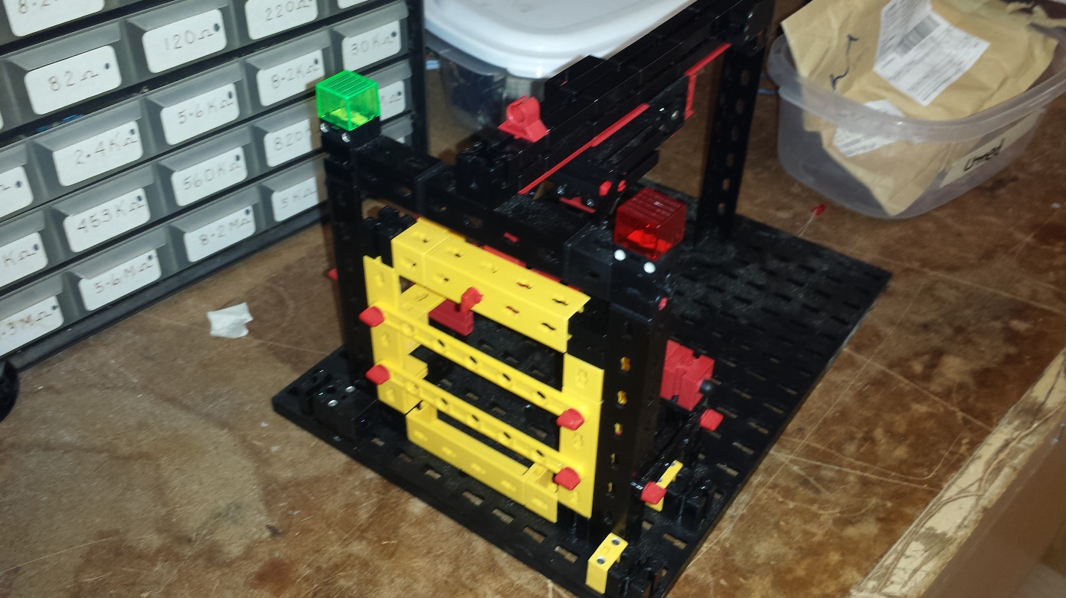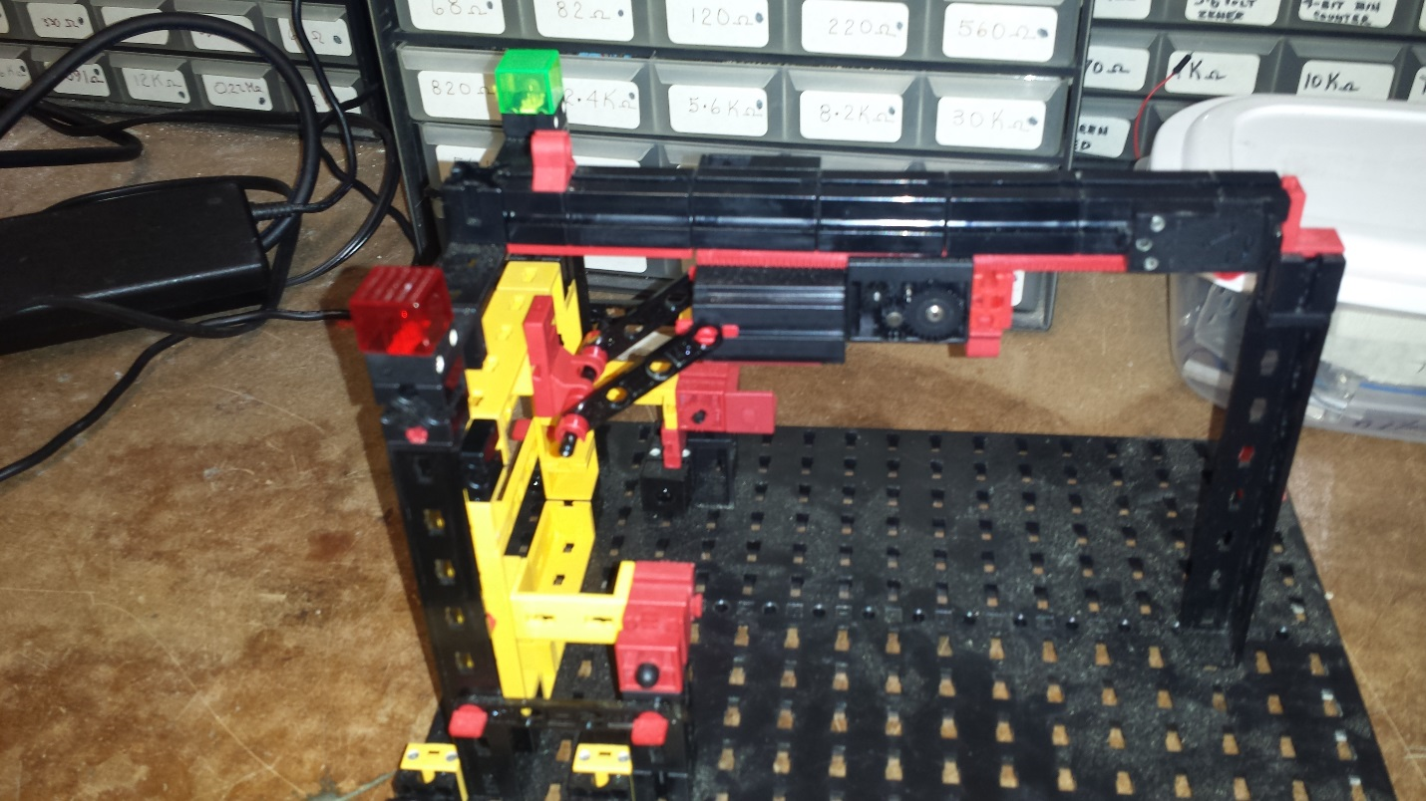

**The final build looks like this. Optionally, you can add lights on top.**

**Place two Photo Transistors ons 1A and 1D. Place two Light Sources on 12A and 12D**

|  |
| --- |
| Wiring |

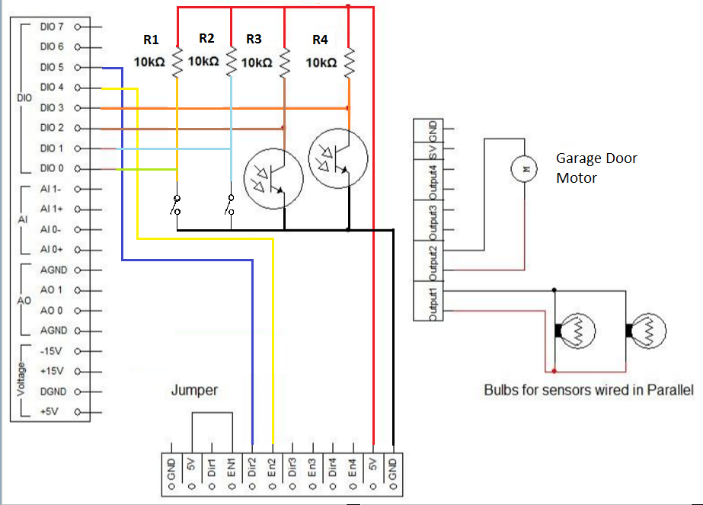

|  |
| --- |
| Program |

Before beginning, take a look at the flowchart below to understand the process and logic behind the Garage Door program.

C:\Users\owner\Downloads\Garage Door - LabView.png

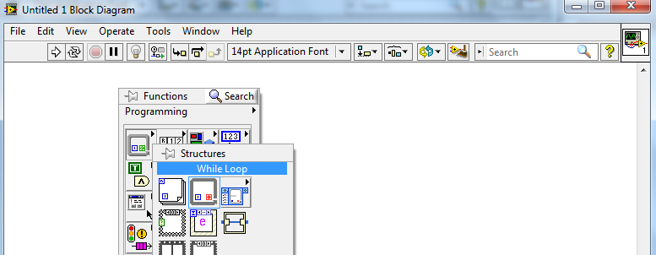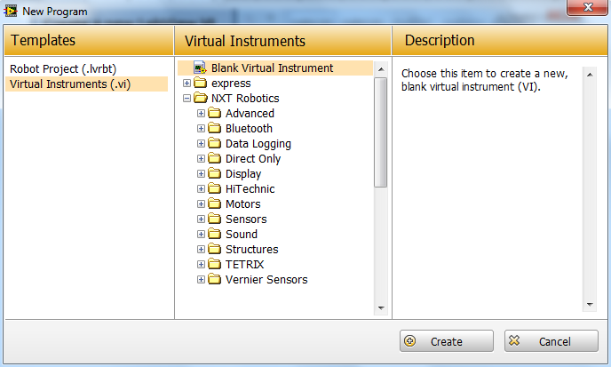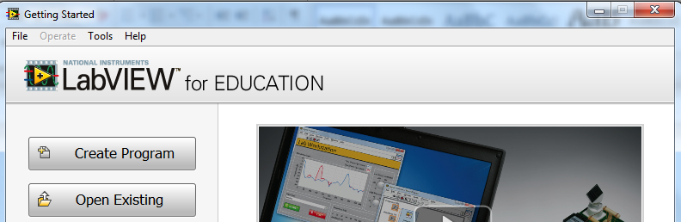

**Select While Loop**

**The block diagram and front panel windows will appear. From the block diagram, right click to open Functions pallet. Go to Structures.**

**Click Create**

**Choose Blank Virtual Instrument**

**Create a new LabView VI**

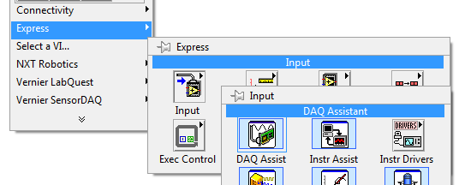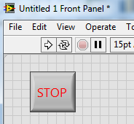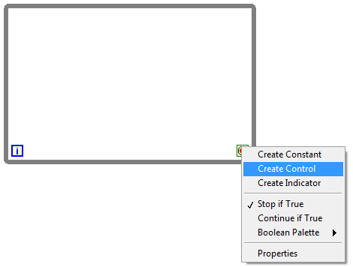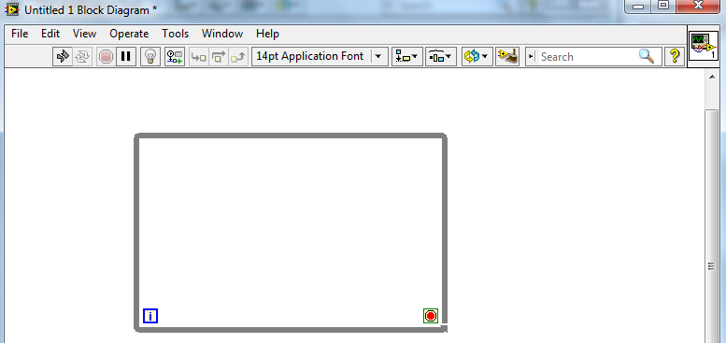

**Select Create Control**

**Right click on the Loop Condition**

**Stop Button will appear on the front panel window. Resize / Style it as you seem fit.**

**Drag mouse to create the while loop**

**You can drag the borders to change the size as you need**

**Select DAQ Assistant**

**Choose Input**

**Open Functions pallet and go to Express**

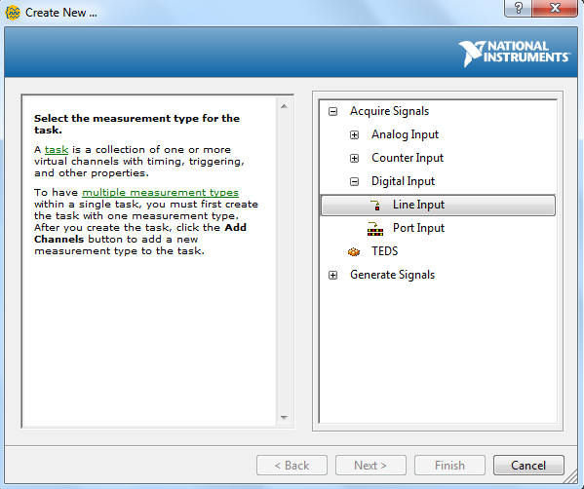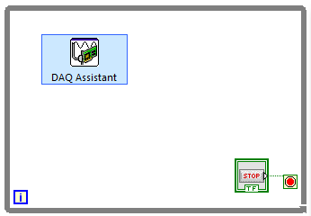

**Select Line Input**

**Choose Digital Input**

**A DAQ Assistant window will appear. Click on Acquire Signals**

**Place DAQ Assistant inside the while loop**

**At this point, make sure that the NI myDAQ device is connected to your computer before proceeding**

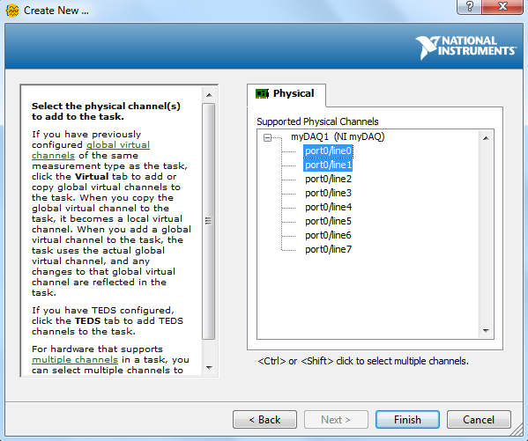

**Select Ports 0 and 1 using the Ctrl Key**

**Your NI device will appear in the list**

**Click Finish**

**If your DAQ device doesn’t appear in the list, make sure to connect it to the computer via a USB. Then close the DAQ window and re-follow the steps to create the DAQ Assistant**

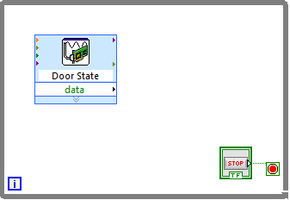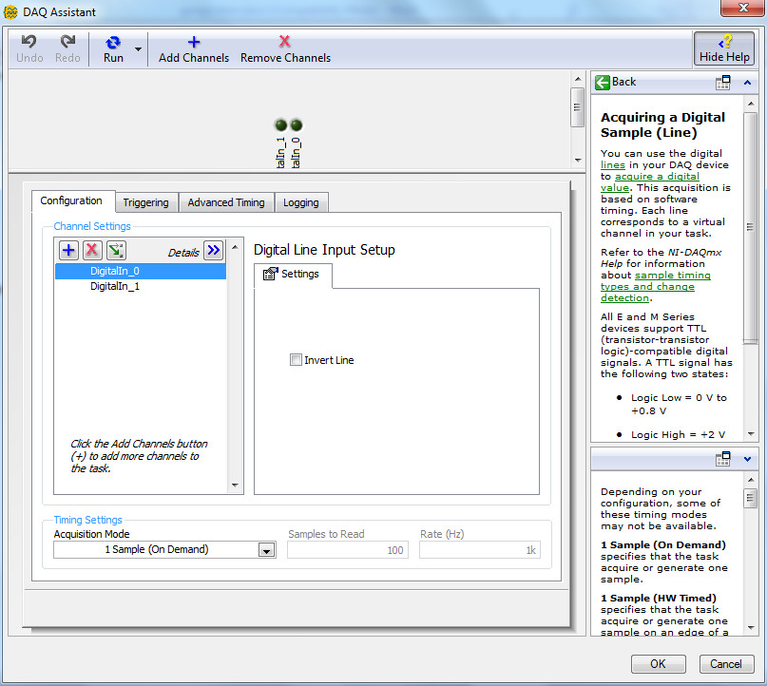

**Double-click to rename the DAQ Assistant to specify its purpose**

**You can expand to see details of what ports you’ve selected**

**It is possible to change the speed or rate at which the input is read. Leave it as it is for now.**

**Click OK to finalize the settings**

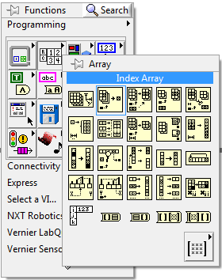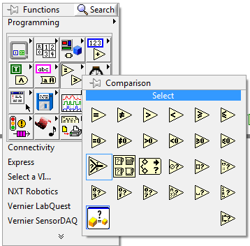

**Create a Select Block**

**Go to Comparison from block diagram Functions pallet.**

**Create an Index Array**

**Open Functions pallet and go to Array**

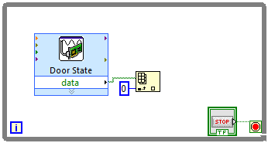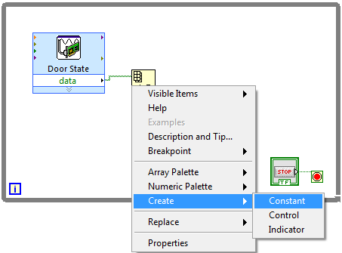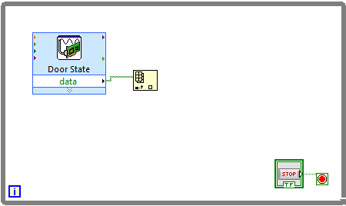

**Right click on the index terminal of Index Array**

**Connect the data terminal of DAQ Assistant to array terminal of Index Array**

**Give the constant a value of 0**

**Select Constant**

**Click on Create**

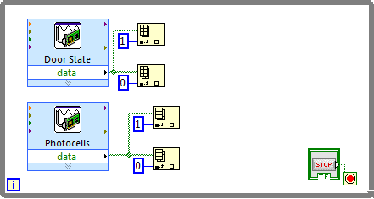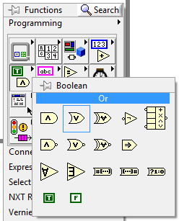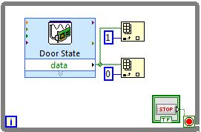

**Create a Or**

**Go to Boolean from the Functions pallet.**

**Create a DAQ Assistant for the photocells using digital ports 2 and 3.**

**Create 2 Index Array and connect them in the same manner**

**Create another Index Array and connect it in the same way**

**Give the constant a value of 1**

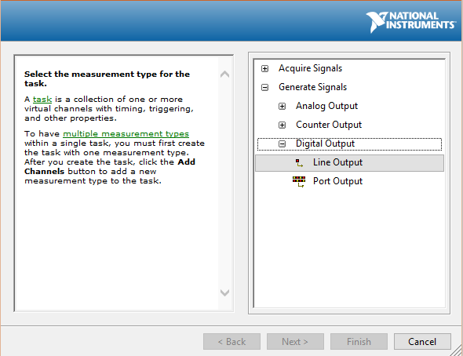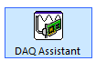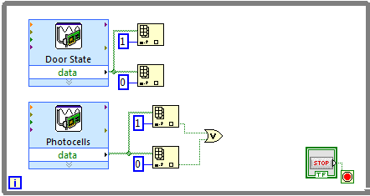

**Select Line Output**

**Choose Digital Output**

**From the DAQ Assistant window, choose Generate Signals**

**Create another DAQ Assistant from the Functions pallet.**

**Connect the element terminal of both Index Array to the x and y terminals of the Or**

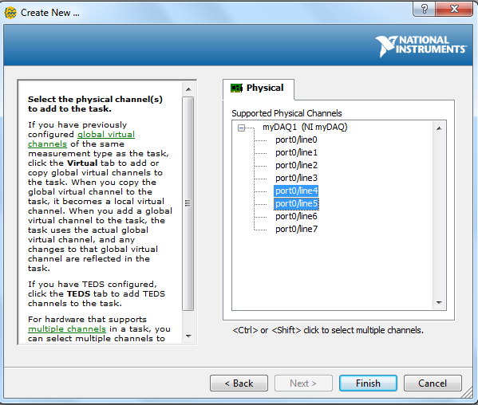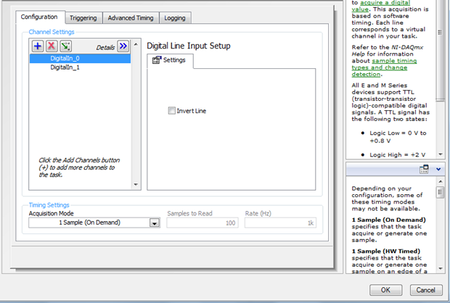

**Select Ports 4 and 5 using the Ctrl Key**

**Leave settings on next window as default and press OK**

**Click Finish**

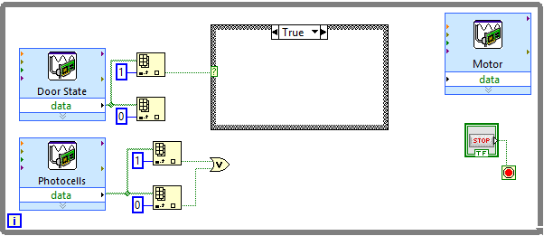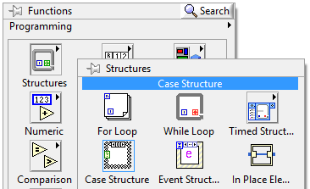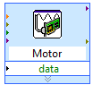

**Create a Select Block**

**Go to Comparison from block diagram Functions pallet.**

**Connect Index Array 1 to the Case Structure**

**Drag the mouse to create the Case Structure inside the While Loop**

**Select Case Structure**

**Open Structures from the Functions pallet**

**Rename the DAQ Assistant to specify its purpose**

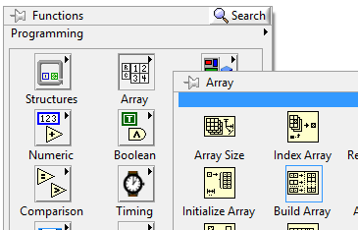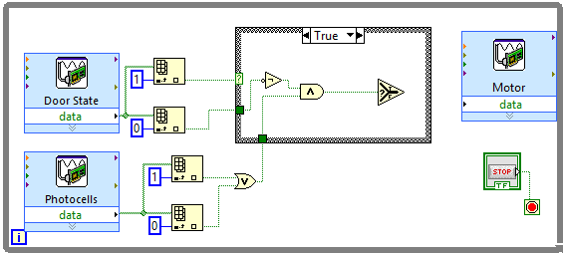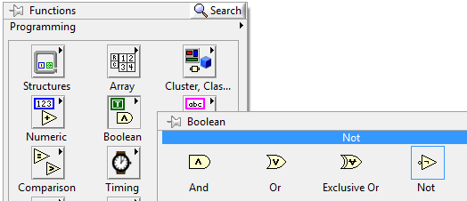

**Create a Build Array**

**From the Functions pallet, go to Array**

**Place the Select & And inside the Case Structure and connect them together**

**Connect Index Array 0 through the Not to the And. Connect the Or to the And.**

**Create a Not**

**Create a And**

**Go to Boolean from the Functions pallet.**

**Expand the size of Build Array from its bottom border to create another array element**

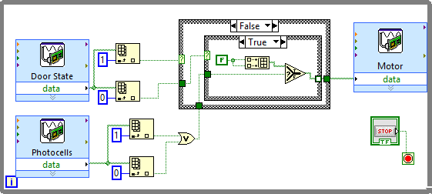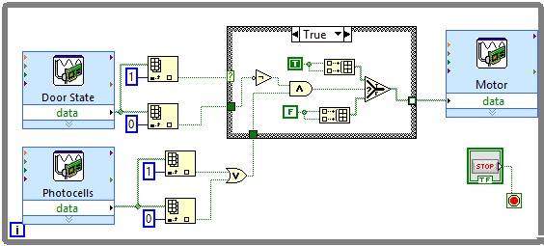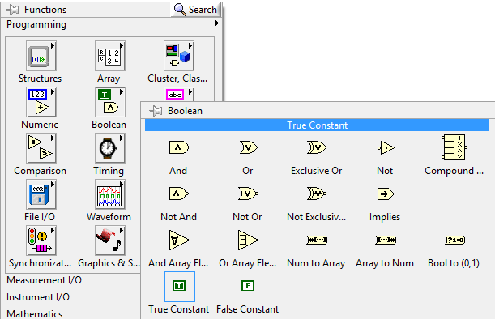

**Create another Build Array and connect it in the same way using False Constant to the f terminal of Select**

**Create a False Constant**

**Create a True Constant**

**Go to Boolean from the Functions pallet**

**Use a Select, Build Array and False Constant to set up the inside of the Case Structure as shown**

**Create another Case Structure inside and connect the Index Array 0 to it.**

**Switch the Case Structure statement to False**

**Note: It’s a best guess that True Constant will give the direction that opens the door. You must test this for yourself and decided whether to use a True Constant or a False Constant.**

**Connect the True Constant to the two terminals of Build Array. Connect this Build Array to t terminal of Select**

**Connect the Select to the Motor DAQ Assistant**

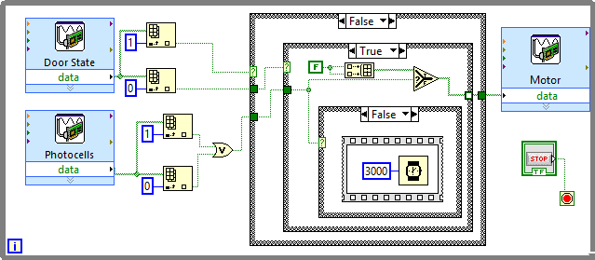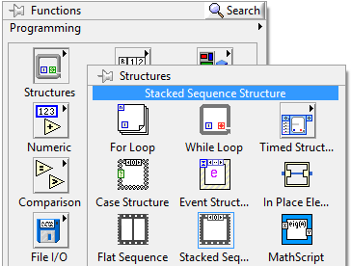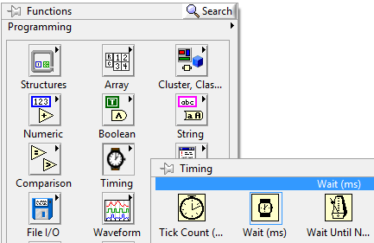

**Select Stacked Sequence**

**From Functions pallet, go to Structures.**

**Create a Wait (ms)**

**Open Timing from the Functions pallet.**

**Place the timer inside the Stacked Sequence which is place inside the Case Structure**

**Add a constant of 3000 to the timer**

**Connect the Or to the Case Structure**

**Switch its statement to false**

**Create a Case Structure inside**

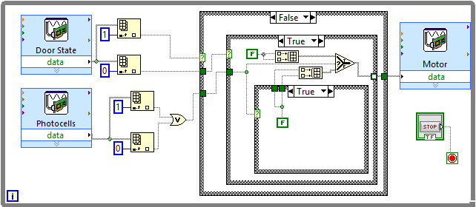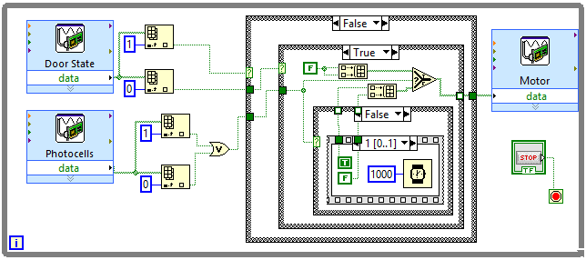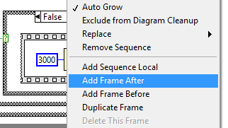

**Switch the Case Structure statement to True**

**Right click on the border of Stacked Sequence and select Add Frame After**

**Create a False Constant inside and connect to the Select through a Build Array**

**Connect the True and False Constants to the Select through a Build Array**

**Place a Wait (ms) with constant 1000 and True and False Constants inside the new frame**

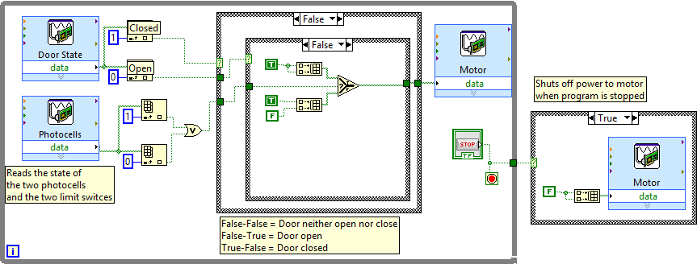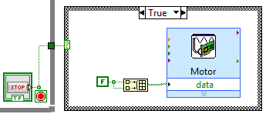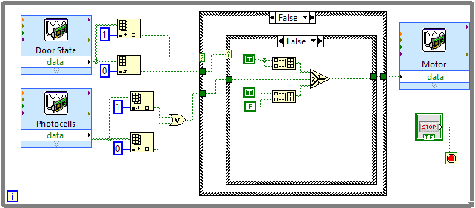

**Switch the Case Structure statement to False**

**Use Select, Build Array and True/False Constants to set up the inside as shown.**

**Congratulations, your LabView VI is now complete. You may wish to add comments to specific portions of your program so that others can more easily understand it. You can do this by double-clicking at an empty space on the block diagram.**

**Connect the Case Structure to the Stop Button Control**

**Create a Case Structure from Functions pallet. Place it outside the While Loop. Set it up as shown in this diagram.**

|  |
| --- |
| Present |

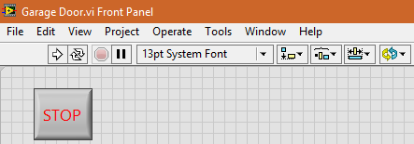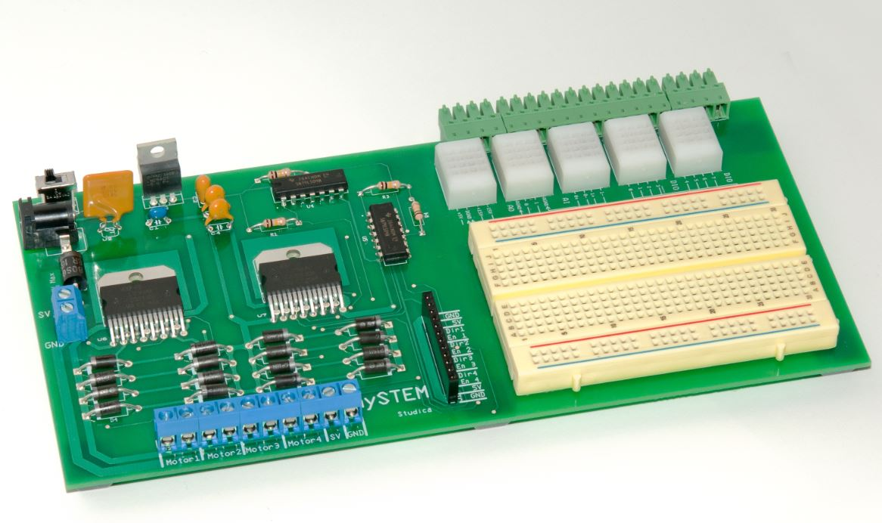

**Press the Stop Button on the front panel after you are done**

**Test your final system before showing it for evaluation. Make sure it works as you would expect. If you find something wrong, refer back to the steps in this tutorial and see if you followed them properly.**

**Make sure it is connected to an external power source**

**Make sure your mySTEM board is turned ON**

**Click the Run button on the toolbar to start the program**